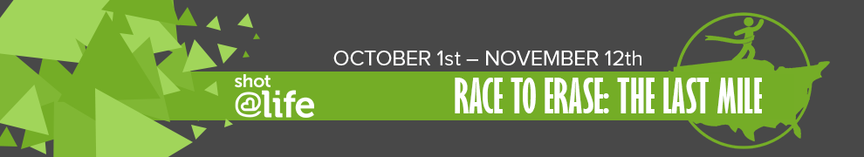

Shot@Life will build on our past calls to action by challenging our supporters to take advocacy actions to help protect children around the world from pneumonia and go the last mile to eradicate polio! From **October 1, 2017 through November 12, 2017**, Champions across the country will be taking advocacy and fundraising actions to virtually “travel” the 5,524 miles from Shot@Life headquarters to Abuja, Nigeria.

Check out a recording of Shot@Life’s kick-off webinar at <http://bit.ly/SALRaceToErase> to learn about the easy ways you/your network can get involved!

You can also email us at [champions@shotatlife.org](mailto:champions@shotatlife.org), head to <http://bit.ly/R2ELastMile>, or register to attend a Champion webinar training on Wednesday, September 27th at 8pm ET at <http://bit.ly/SALChamp927> or Wednesday, October 23rd at 8pm ET at <http://bit.ly/SALChamp1023>.

We would love to see photos of the events you are holding and the actions you are taking, so email them or tag us @ShotAtLife or use #vaccineswork.

All activities must be completed between October 1st and November 12th and submitted online through the Champion Community by November 16th for “miles” to qualify.

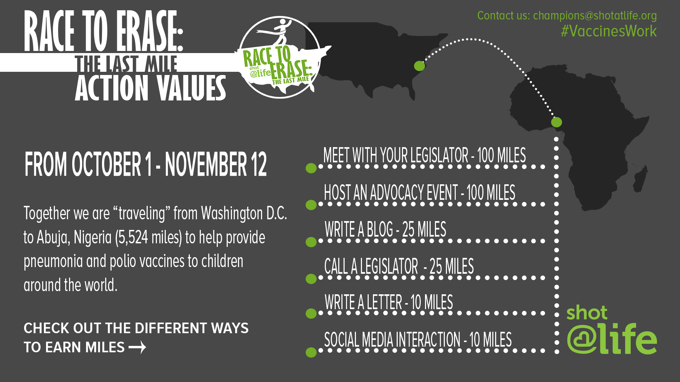

Champions that reach 500 miles will receive free registration to our Champion Summit February 12-14, 2017 in Washington, DC pending regular acceptance.

The following toolkit is everything you will need to successfully advocate during R2E. We have included

instructions and resources for each action item. If you have any questions or would like any additional

resources such as handouts, t-shirts, or pens, email us at [champions@shotatlife.org](mailto:champions@shotatlife.org).

# **Meeting with Your Legislator: 100 Miles**

Meeting with your legislators is the best way to participate in Race to Erase: The Last Mile. If you are not already a trained advocate (Shot@Life Champion), we would be happy to connect you with others in your area. This toolkit includes information on other actions you can take.

While you can meet with an office at any point in the activation, you should request a meeting right away. Don’t be afraid to follow-up with a call a week after your initial request! If possible aim to have your meeting around World Polio Day (October 24th). This time of year can be busy for Congressional offices (and you!), so if a different time during the activation works better, that is okay too.

## *Sample Meeting Request*

Subject: Constituent Meeting Request

[Month] [Date], 2017

Dear [Senator/Representative] [Last Name],

As your constituent and a [ex. Student, teacher, mother, business owner, nurse, etc.], I would like to schedule a meeting with you in your district office to discuss an issue that I am very passionate about: global vaccines.

I would like to discuss the importance and value of US funding for programs that immunize the world’s most vulnerable children from devastating—but preventable – infectious diseases. I have pledged my support to Shot@Life, a national grassroots campaign with members in all 50 states that educates, connects and empowers Americans to champion vaccines as one of the most cost-effective ways to save the lives of children in developing countries. I would like the opportunity to share my passion about this issue with you.

I would appreciate the opportunity to meet with you at your earliest convenience. I can be reached at the following email, [your email address], or [phone number] to arrange a meeting. I will follow-up later this week, as appropriate, pending confirmation of a meeting time. I look forward to hearing from you on this issue.

Sincerely,

[Your First + Last Name]

[Address]

[Phone Number]

Meeting with a member of Congress or their staff shouldn’t be intimidating. Your legislator was elected to represent you! You can always explain Shot@Life and the importance of global childhood immunizations to a friend or family member and bring them along. You can also reach out to our team at [champions@shotatlife.org](mailto:champions@shotatlife.org), and we will connect you with other advocates in your area. Whether you are the only constituent in the meeting or attend as part of a group, print off and use the following talking points as an outline for your meeting!

*You should also print off a copy of our leave-behind materials for each office you meet with.*

***“How do Shot@Life Champions fight for global vaccines?***

Grassroots champions like us raise awareness and funds to support the work of the U.S. government, United Nations, Gavi, the Vaccine Alliance, and others organizations to improve access and equity in developing countries to cost-effective, high-impact vaccines

***“Where is global vaccine funding located in the budget and how is it allocated?***

Global vaccine funding is located in two appropriations bills:

--State, Foreign Operations and Related Programs (SFOPS)

--Labor, Health and Human Services, Education, and Related Agencies (LHHS)

|  |  |  |
| --- | --- | --- |
| **Activity** | **Agency** | **Bill** |
| Polio | CDC | LHHS |
|  | USAID | SFOPS |
| Measles | CDC | LHHS |
| Gavi | USAID | SFOPS |
| UNICEF | State | SFOPS |

***“Who can I contact to become more involved?”***

**House Global Health Caucus**

Co-Chairs:

Rep. Betty McCollum (D-MN)

(Jenn Holcomb; (202) 225-6631)

Rep. Dave Reichert (R-WA)

(Colin Swanson; (202) 225-7761)

Interested in making a statement for the record or learning more about global vaccines?

Contact Brian Massa; bmassa@unfoundation.org

FAQs

## *Talking Points for In-District Meeting*

**Fall 2017**

**Section I: Introduction**

* *Have each member of your group introduce themselves: share where you’re from, what organization you’re affiliated with, and why S@L is important to you!*
* [I/We] represent the *Shot@Life* campaign in your [district/state]. The campaign is part of the UN Foundation and educates, connects, and empowers Americans to champion global vaccines as one of the most cost-effective investments the U.S. government can make to save the lives of children in developing countries.
* We support this cause in our communities by holding events, raising funds, and advocating to our elected officials locally. We are here today to talk about our passion for global childhood immunization and how [Senator/Representative X] can play a leadership role in ensuring all kids have a shot at life.

**Section II: Why Global Vaccine?**

**The Problem: Kids Die Every Day from Vaccine-Preventable Diseases**

* Every 20 seconds, a child dies from a vaccine-preventable disease, claiming the lives of 2.5 million children every year and accounting for nearly one third of all childhood deaths.

**The Solution: Vaccines!**

* Vaccines are one the safest, most cost-effective ways to save children’s lives, improve health, and ensure long-term economic prosperity.
* For less than $2 a child can be safely vaccinated against measles and rubella.
* 30 years ago, polio paralyzed over 1,000 kids each day, but thanks to the polio vaccine, cases have dropped 99.9% and the world is now nearly polio-free.
* In the past 20 years, immunization has prevented 20 million deaths globally.
* The UN is a central partner in amplifying US investment in global vaccines, from UNICEF procuring vaccines that reach 45% of the world’s children, to WHO strengthening health systems and coordinating emergency response efforts.
* *Share your story:* *Why are you passionate about immunizing children? Have you been involved in your community or have a personal connection?*

**Additional Background on U.S. Global Vaccine Activities**

The US government has a long history of bipartisan support for global health and global immunization programs delivered through the work of the U.S. Agency for International Development (USAID), the U.S. Centers for Disease Control and Prevention (CDC), and international organizations like GAVI, the Vaccine Alliance, the World Health Organization (WHO), and the United Nations Children’s Fund (UNICEF)

**Section III: Why Congress Should Act Now**

* *Global Health investments protect U.S. security interests:* Preventing infectious diseases overseas protects

Americans at home and abroad, and USG funding for immunization activities **helps nations build strong health systems** **to more efficiently respond to disease outbreaks, such as the Ebola crisis**.

* *High return on investment:* On average, every **$1 invested in immunization produces $44 in savings** in healthcare costs, lost wages, and productivity due to illness – a global health best-buy!Funding Gavi with $290 million for FY18 will contribute to an estimated **9.2 million children immunized in 2018, leading to 164,000 lives saved and $2.7 billion in additional economic savings from averted costs of death, disability, and health care.**
* *It’s the Right Thing to Do:* Supporting global vaccines is **part of our national character and a moral obligation**. We cannot turn our backs when children die from preventable diseases.

**More Vaccine Success Stories!**

* 30 years ago polio cases appeared in 125 countries across the globe, but now only three countries – Pakistan, Afghanistan, and Nigeria – have active transmission.
* Since 2000, the measles vaccine has prevented 20.3 million deaths and reduced measles-related deaths by 79%. Measles has now been eliminated from the Americas region.
* GAVI has introduced the pneumococcal vaccine in over 50 countries, a year ahead of schedule, immunizing roughly 47 million children.

**Section IV: The ‘Ask’**

1. **[Both the House and Senate have approved appropriations bills that fund our programs at the level we are requesting for FY18. But a final package has not yet been adopted, so we need to keep pushing for final passage!]**
2. **For Fiscal Year 2018, Shot@Life is requesting Congress fully fund U.S. government global vaccine activities:**

* **$233 million for Polio eradication**, including:
  + **$174 million for CDC** through the Labor-HHS Appropriations Subcommittee
  + **$59 million for USAID** through the State and Foreign Operations (SFOPS) Appropriations Subcomm.
* **$50 million for CDC measles elimination** through Labor-HHS Appropriations Subcommittee
* **$290 million for Gavi**, the Vaccine Alliance, through SFOPS
* **$132.5 million for UNICEF**, through SFOPS

**Section V: Closing & Sharing Your Experience**

* ***Thank the member/staffer*** *for their time and ask if they have any questions. If they ask any questions you can’t answer, don’t worry! Tell them to contact Brian Massa, Senior Manager for Global Health Advocacy, at* [bmassa@unfoundation.org](mailto:bmassa@unfoundation.org)
* ***Give the staffer your folder*** *with the leave-behind materials (Fiscal Year 2018 Appropriations Requests on pages 5-9).*
  + For your reference, here issome helpful information that explains more about the value of U.S. investments in the fight for global vaccines, our specific funding request, and ways for the Senator/Representative to get involved.
* *Ask the staffer/member to join you in a photo in front of the office sign and share it on social media, tagging with* ***@Shot@Life*** *and* ***#vaccineswork***

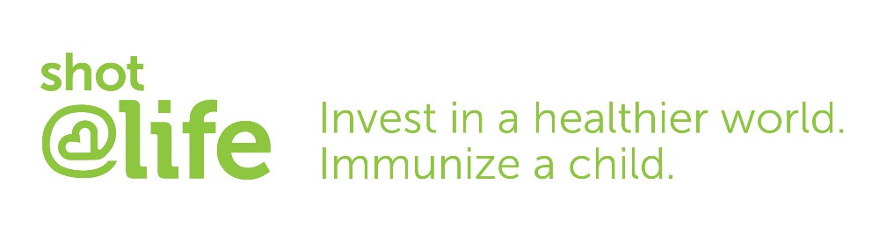

FISCAL YEAR 2018 APPROPRIATIONS REQUESTS *(updated 9.8.17)*

Contact: Brian Massa, Senior Manager for Global Health Advocacy, Shot@Life ([bmassa@unfoundation.org](mailto:bmassa@unfoundation.org))

**USAID Global Health Programs (GHP) and State Department**

*(all figures in millions USD)*

|  |  |  |  |  |  |  |
| --- | --- | --- | --- | --- | --- | --- |
| **Program** | **FY17 Omnibus** | **FY18 President’s Budget** | **FY18 President’s Request vs. FY17 Omnibus** | **FY18 House SFOPS Mark** | **FY18 Senate SFOPS Mark** | **FY18 S@L Request** |
| **Polio (USAID)** | $59.0 | $44.0 | -$15.0 (-15.5%) | $59.0 | $59.0 | $59.0 |
| **Gavi (USAID)** | $275.0 | $290.0 | +$15.0 (5.5%) | $290.0 | $290.0 | $290.0 |
| **UNICEF (State)** | $137.5 | $0.0 | -$137.5 (-100%) | $132.5 | $132.5 (+$5.0 FGM) | $132.5 |

**U.S. Centers for Disease Control and Prevention (CDC)**

*(all figures in millions USD)*

|  |  |  |  |  |  |  |
| --- | --- | --- | --- | --- | --- | --- |
| **Program** | **FY17 Omnibus** | **FY18 President’s Budget** | **FY18 President’s Request vs. FY17 Omnibus** | **FY18 House LHHS Mark** | **FY18 Senate LHHS Mark** | **FY18 S@L Request** |
| **Polio Eradication (CDC/GID)** | $174.0 | $165.0 | -$9.0 (-5.2%) | $174.0 | $174.0 | $174.0 |
| **Measles (CDC/GID)** | $50.0 | $41.0 | -$9.0 (-18%) | $50.0 | $50 | $50.0 |

**Gavi, the Vaccine Alliance**

In 2000, Gavi, the Vaccine Alliance, was launched as an innovative public-private partnership to fund the purchase and delivery of life-saving vaccines for children in the world's poorest countries, where 85% of the world’s unvaccinated children live. Since inception, Gavi has partnered with developing countries and mobilized support from the United States Government, the Bill & Melinda Gates Foundation, the private sector and pharmaceutical industry, UNICEF, WHO, the World Bank and others, to help immunize over half a billion children. This investment has saved more than eight million lives. In January 2015, Gavi convened its second replenishment forum where it marshalled $7.5 billion in additional donor pledges for the 2016-2020 strategic period. With this additional funding, Gavi-eligible countries will be able to immunize an additional 300 million children, saving 5-6 million lives.

As one of the Gavi’s original six donor countries, the United States has been a critically important partner. Since 2000, the United States has contributed just under $1.4 billion to Gavi. Immunizations and vaccines are a critical part of achieving the important goal of ending preventable child deaths and Gavi’s activities support and bolster the effectiveness of other USG-funded child survival and health activities. If FY18 requested levels are appropriated, the U.S. will fulfill its pledge of $1 billion for years 2015 to 2018, which we anticipate. Our continued support of Gavi at FY18 levels would mean significant strides will be able to be achieved in their goal of immunizing an additional 300 million children and saving an additional 5 to 6 million lives between 2016 and 2020. **FY19 Request for Gavi Immunization Activities: $290 million**

**Polio Eradication**

Thanks to increased funding by the U.S. and the coordinated efforts of the Global Polio Eradication Initiative (GPEI) End Game Strategy, the opportunity for a polio-free world is within reach. As a result of GPEI partner organizations, cases have dropped 99.9% globally since 1988, and the virus remains endemic to only three countries, Pakistan, Afghanistan, and Nigeria. The partnership achieved important milestones in 2016, including the phased transition from oral polio vaccine (OPV) to inactivated polio vaccine (IPV), which occurred over a 10-day period in April and involved the coordinated efforts of 155 countries. This successful transition will further reduce the risk of rare instances of vaccine-derived poliovirus (VDPV).

Strengthened political ownership and financial commitment in Pakistan has significantly increased vaccine coverage for children in that country. The percentage of children in priority districts who have never received a single dose of polio vaccine decreased from nine percent in 2014 to zero percent in 2016. Over this same timeframe, children in Pakistan who have been repeatedly missed by follow-up campaigns has dropped from 24 percent to just four percent. Improved surveillance in Afghanistan and a synchronized cross-border task force has also kept the country largely polio-free.

The August 2016 outbreak of polio in Nigeria was a setback, after the country had nearly completed three years without a detected case. However, it should be viewed in the greater context of significant progress in the country and on the African continent. As recently as 2012, Nigeria accounted for more than half of all polio cases worldwide. Cases are now limited to a very small area in the northeast where armed conflict had obstructed access of vaccinators and public health officials. The outbreak was in fact detected by improvements to surveillance that detected low-level circulation of the virus. After identifying the outbreak, GPEI partners mobilized a massive vaccination campaign that reached over 40 million children across five border countries in the Lake Chad region.

Polio eradication is within reach, and now is the time for continued political commitment to realize what will be one of the greatest public health achievements in history and ensure that all children live polio-free, forever. **FY18 Request for CDC Polio Eradication Efforts: $174 million**

**FY18 Request for USAID Polio Eradication Efforts: $59 million**

**Measles Elimination**

The Measles and Rubella Initiative (M&RI) was founded in 2001 to ensure that no child dies from measles or is born with congenital rubella syndrome. Since its creation, this global public-private partnership has driven a 79 percent reduction in measles mortality, preventing over 20.3 million deaths. Over this timeframe, measles dropped from the fifth cause of child mortality to the fourteenth, making it the single greatest contribution to reducing global child mortality. In 2015 the partnership supported the vaccination of 178 million children against measles or measles-rubella across 39 countries, contributing to 85 percent of all children covered worldwide by at least one dose of measles vaccine. The organization has also strengthened surveillance through a global network of over 720 laboratories in nearly all WHO member states, and developed preparedness measures to facilitate rapid response during a measles outbreak. Yet despite these positive steps, 2016 was marked by serious outbreaks around the world, from South Sudan, to Ethiopia, to China. An estimated 134,000 children died from measles in 2015, or roughly 400 every day.

Significant funding shortfalls also threaten the elimination target date of 2020. In 2016, for instance, a $60 million funding gap left 20 million children unvaccinated and impacted M&RI’s ability to quickly detect, prevent, and respond to measles cases. For most of 2016, the African region lacked sufficient funds to order diagnostic kits and in other regions surveillance activities have had to be significantly cut back due to lack of funding. M&RI is currently conducting a review to determine financial requirements for measles-rubella activities through 2020, and expects to release this information by Q1-Q2 2017. **FY18 Request for CDC Measles Elimination Efforts: $50 million**

**United Nations Children’s Fund (UNICEF)**

For more than 50 years, UNICEF has been a world leader in immunizations, partnering closely with the US government and others to reach and save the world’s most vulnerable children from devastating diseases. In 2015, UNICEF procured 2.8 billion doses of vaccines for 95 countries. These activities reached 45 percent of the world’s children under the age of five, and included facilitating the delivery of 296 million doses of measles vaccine and 1.6 billion doses of the oral polio vaccine.

UNICEF is responsible for procuring vaccines for Gavi, the Vaccine Alliance, and also purchases vaccines for other global campaigns not covered by Gavi. Due to UNICEF’s large purchasing power, the United Nations agency cut in half the cost of the pentavalent vaccine that protects tens of millions of children from potentially deadly infectious diseases, including diphtheria, tetanus, and pertussis. UNICEF works in-country to provide vital services at the community level to ensure that vaccines that reach the country’s borders are efficiently and effectively delivered to even the poorest children in the most difficult to reach areas. **FY18 Request for UNICEF: $132.5 million**

*About the Shot@Life Campaign*

*The Shot@Life campaign educates, connects, and empowers individuals to champion global vaccines as one of the most cost-effective, high-impact health interventions that save children’s lives in developing countries. As America’s largest grassroots organization dedicated solely to advocating for global immunization programs, Shot@Life ensures U.S. policymakers continue to strongly support global immunization efforts through USAID, the State Department, and the U.S. Centers for Disease Control. The campaign also raises funds through individual giving and corporate partnerships that aid the coordination, purchase, delivery, and administration of vaccines to the world’s most vulnerable children. Learn more at* [www.shotatlife.org](http://www.shotatlife.org)*.*





Let us know how your meeting went by submitting a report on the Champion Community! If a member or

staffer had any questions you couldn’t answer, this is the perfect opportunity to send a follow-up email and

continue building a relationship with the office.

# **Host an Advocacy/Fundraising Event: 100 Miles**

Hosting an advocacy or fundraising event is the easiest 100 miles you’ll ever “travel”! Planning an event is a great way to raise awareness and support our issue. Below are some ideas for events you can plan, but we encourage Champions to get creative (you know what would work best in your community!) Our team is always here to support you, so feel free to email us at [champions@shotatlife.org](mailto:champions@shotatlife.org).

There are a limited number of small scholarships to hold advocacy and fundraising events. Email your event idea and a proposed budget to [champions@shotatlife.org](mailto:champions@shotatlife.org) to apply!

GFWC members have a separate scholarship for up to $100 to use towards an event. Apply at <http://bit.ly/GFWCShotLifeGrant>.

If you collect donations on behalf of Shot@Life you submit them online at [www.shotatlife.org/donate](http://www.shotatlife.org/donate) or by sending them to the address below. If you are affiliated with a GFWC club, make sure to include that with your donation.

Shot at Life

PO Box 96399

Washington, DC 20090

Phone Bank

Get a group of friends together for pizza and drinks and ask them to take a few minutes while hanging out to make five phone calls. One to each of your two U.S. Senators, one to your Representative in the House, and two calls to members of your network to ask them to make the same calls and/or a donation to Shot@Life.

World Polio Day (October 24th) is a great day to plan your phone bank! You will join advocates around the country in telling your members of Congress how close the international community is to eradicating polio and the importance of strong funding for polio programs. Together we can make the largest impact!

Training Party

If you have at least five friends or family members that would like to be trained as Shot@Life Champions, our staff would be happy to schedule a training webinar for you. This hour and a half training would consist of learning about Shot@Life, how to advocate for global childhood immunizations, and taking your first advocacy action. Email [champions@shotatlife.org](mailto:champions@shotatlife.org) to request a training.

Happy Hour or Restaurant Event

See how much proceeds you can raise for Race to Erase in just one night. Host a happy hour or restaurant get-together and ask the business to devote a certain percentage (approximately 15%) of the night’s proceeds to Shot@Life. Keep in mind that early in the week bars and restaurants are often glad to fill the space & contribute to a great cause! Make sure you set this up with them ahead of time.

50/50 Raffle

A 50/50 raffle is a great fundraising activity to add to another event. 50% of the money raised goes towards an organization and 50% goes towards a winning individual. You can offer 1 ticket for $1 or 6 tickets for $5.

Letter to the Editor Party

Placing media advocacy pieces gets the word out in your community. Choose a leader in your network who

has placed pieces in the past or is a great writer to lead the group. Make sure you submit letters to different

local papers and pay attention to word limits. These are usually around 250 words, but check with your local publication. You can use our LTE template as a starting point!

Lunch and Learn

Get a group of friends together for a lunch outing and let them know about Shot@Life and Race to Erase. This could be the first step to recruiting them as a Champion. The goal of your Lunch and Learn could be to set up a Champion training or to meet with your members of Congress. Think about planning a date for your Lunch and Learn group to visit your representatives’ in-district offices together.

# **Submit a Letter to The Editor: 25 Miles (Additional 25 Miles Upon Publication)**

A great way to raise awareness is by submitting a Letter to the Editor (LTE). Not only will it inform your community about the importance of global vaccines, it may even appear in a publication your member of Congress reads! Below is a sample text you can use as a starting point for your own LTE. You can also submit LTEs through our online tool at <http://bit.ly/R2ELastMile>.

One and a half million children die each year from diseases that could have been prevented by a vaccine. This is because, shockingly, one in five children in the world still lacks access to the basic childhood vaccines we take for granted here in the United States. This is a problem with a solution…so we must act!

Great strides have been made over the last decade to give more families access to immunizations for their children. The measles vaccine alone has prevented an estimated 20.3 million deaths from 2000-2015, a 79% reduction! We cannot stop now and lose the significant gains we've made.

In addition to the moral and humanitarian impact, giving children around the world access to immunizations increases global and national security. In today’s interconnected world, these deadly diseases don’t stop at borders, as demonstrated by recent measles outbreaks and Ebola cases in the U.S. Immunizations are also a financially sound investment; for every $1 spent on childhood immunizations, you get $44 in economic benefits. That includes saving the money that families lose when a child is sick and a parent can’t work.

The United Nations Foundation’s *Shot@Life* campaign is asking U.S. legislators to help reduce vaccine-preventable childhood deaths around the world by providing adequate funding for global vaccine programs. Call **[insert Member’s name]**’s office and ask them to strengthen and prioritize funding for global vaccine programs through partners such as the United Nations, Gavi (the Vaccine Alliance), CDC, and USAID.

We all have a stake in the outcome and parents around the world will sleep more soundly knowing their children are protected.

Once you submit your LTE, let us know on the Champion Community. We want people to wake up on World Polio Day and read about the need to eradicate this debilitating disease!

# **Call Your Legislator: 25 Miles**

You can earn up to 75 “miles” by calling your members of Congress. Follow the steps and talking points below to reach out to your legislators by phone.

1. Call the Capitol Hill main line at (202) 224-3121
2. Ask to be connected to your Senator or Representative’s Office
3. Tell the staff member who answers the phone that you have an opinion on global health and foreign aid that you would like to share with the member of Congress and ask if you can leave that opinion with the staffer.
4. Deliver your talking points (In-District meeting talking points)
5. Ask if the staffer requires any follow-up information. Most Congressional offices track phone calls by area code. Some may ask for your name, some may not.
6. You may also ask if the member has a current stance on global vaccines, global health, or foreign aid. Request a reply with a response indicating the member’s position on the matter.
7. Thank the staffer for his or her time.
8. Log your meeting in the Champion Community!

# **Write A Letter: 10 Miles**

Due to security measures, the fastest way to send a letter to your member of Congress is via email. If you would prefer to send a physical letter to an office, you can search for mailing addresses at [whoismyrepresentative.com](http://www.whoismyrepresentative.com).

Feel free to customize the draft below or send letters online at <http://bit.ly/R2ELastMile>. No matter how you send a letter, make sure to report your actions in the Champion Community!

Dear [Member],

I strongly urge you to prioritize robust funding for global vaccine and immunization programs. As someone who is dedicated to ensuring that life-saving vaccines are provided to the world’s most vulnerable children, I ask that you work to ensure continued US leadership in these smart global health investments.

Every 20 seconds, a child dies from a vaccine-preventable disease, claiming the lives of 1.5 million children every year – nearly ¼ of all childhood deaths. Yet vaccines are one of the safest, most cost-effective ways to ensure that every child has a shot at life.

In the past 20 years alone, immunization has averted 20 million deaths globally, while providing $16 in healthcare savings for every $1 invested. Polio cases have decreased by 99.9% since 1988, and measles deaths have decreased by 79% since 2000. However, even one death from a vaccine-preventable disease is too many.

The House and Senate appropriations committees have approved legislation that provide strong investments in global immunization programs, but much work remains before the end of the fiscal year. I call on you to reject the White House's attempt to drastically cut foreign assistance.  Please support final passage of an FY18 appropriations measure that provides $290 million for Gavi, the Vaccine Alliance, and maintains the following accounts at FY17 levels:

* $233 million for Polio eradication, including:
* $174 million for CDC through the Labor-HHS Appropriations Subcommittee
* $59 million for USAID through the State and Foreign Operations (SFOPS) Appropriations Subcommittee
* $50 million for CDC measles elimination through the Labor-HHS Appropriations Subcommittee
* $275 million for GAVI through the State and Foreign Operations (SFOPS) Appropriations Subcommittee
* $132.5 million for UNICEF through the State and Foreign Operations (SFOPS) Appropriations Subcommittee

[Insert Personalization]

I am a supporter of *Shot@Life*, a campaign that connects and empowers Americans to champion vaccines as one of the most cost-effective ways to save the lives of children in developing countries.

Please – use your voice in Congress to give every child a shot at life.

Sincerely,

*[Signature]*

[Your First + Last Name]

[Address]

[Phone number]

# **Social Media Interaction: 10 Miles**

Up to ten social media posts can count towards your “miles”. Two posts directed at any one member of Congress (total of six), one additional post for World Polio Day on October 24th, one additional post for World Pneumonia Day on November 12th, and two highlighting Get A Shot. Give A Shot. You can find sample posts below or post directly from our social media toolkit online at <https://thesocialpresskit.com/shotlife-digital-toolkit>. Search for your member of Congress on social media at <https://mobile.twitter.com/cspan/lists/members-of-congress/members?lang=en>.

* 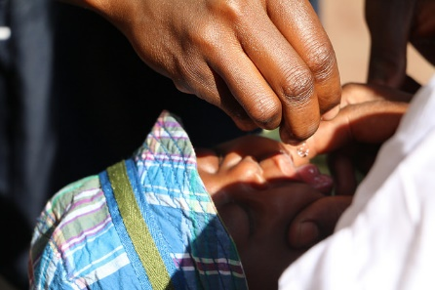Because of the polio vaccine, five million people who would have contracted the disease are able to walk #fightpolio #vaccineswork
* @member Polio has been 99% eradicated. Support legislation to #finishthefight.
* Pneumonia causes almost 1 in 6 of all child deaths under 5 or more than 2500 every day #FightPneumonia
* To improve child survival, we must #FightPneumonia and get vaccines where they are needed
* 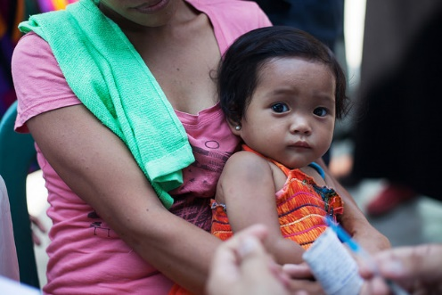@member immunization is 1 of the most cost-effective ways to prevent pneumonia. #FightPneumonia #vaccineswork
* Help #GiveAShot through @ShotAtLife when you get a flu shot @Walgreens - 20+ million donated so far! <http://bit.ly/1Kw2jA2>
* Your flu shot can make a difference. Help give a child a @ShotAtLife when you get your flu shot @Walgreens. <http://bit.ly/1Kw2jA2>

